


WE ARE COMMITTED TO

R

TO FIND OUT MORE VISIT: BOWLSENGLAND.COM/SAFEGUARDING
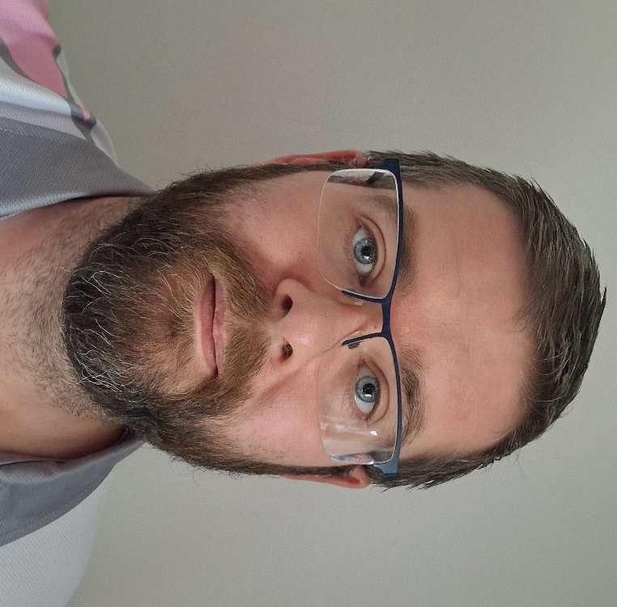
Telephone:
07894 103295

Email:
Mbrennan1986@gmail.com

For emails, please use the subject heading
“WBC Safeguarding”
YOUR CLUB SAFEGUARDING OFFICER IS MARK BRENNAN

URGENT CONCERNS
If the individual is at immediate risk of significant harm, call the police without delay

NGB LEAD SAFEGUARDING OFFICER:
Juliette Maggs-Bowen
juliette.maggs-bowen@bowlsengland.com

